Module 8 – Working with Mapping in Tableau

8.1 Working on Coordinate Points
Definition
Coordinate points are geographic locations represented using:
- Latitude → North/South position
- Longitude → East/West position
Tableau uses these coordinates to place marks accurately on maps.

Understanding Latitude & Longitude
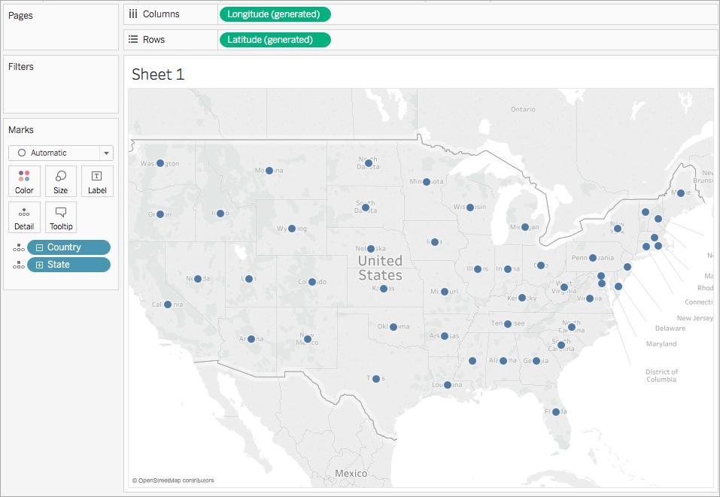
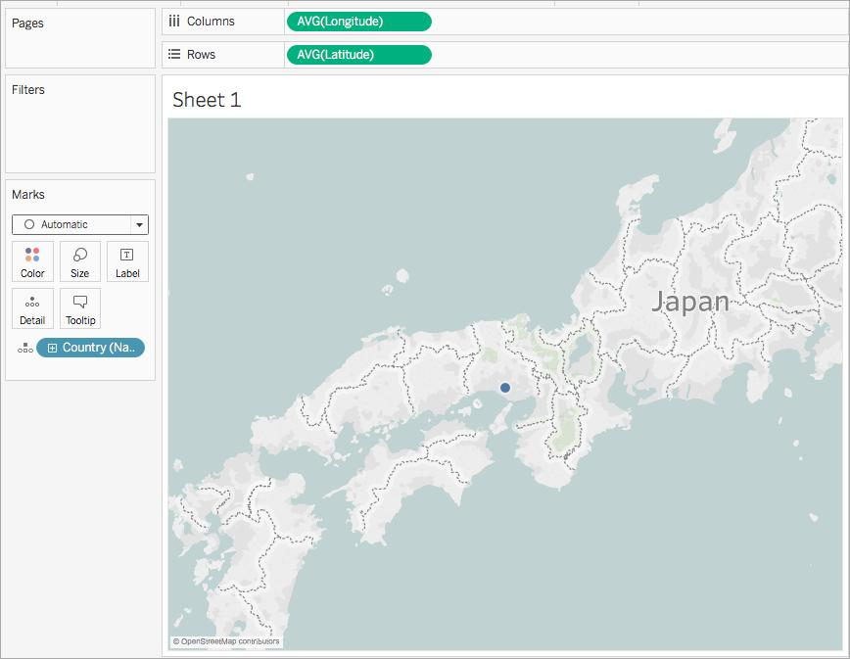
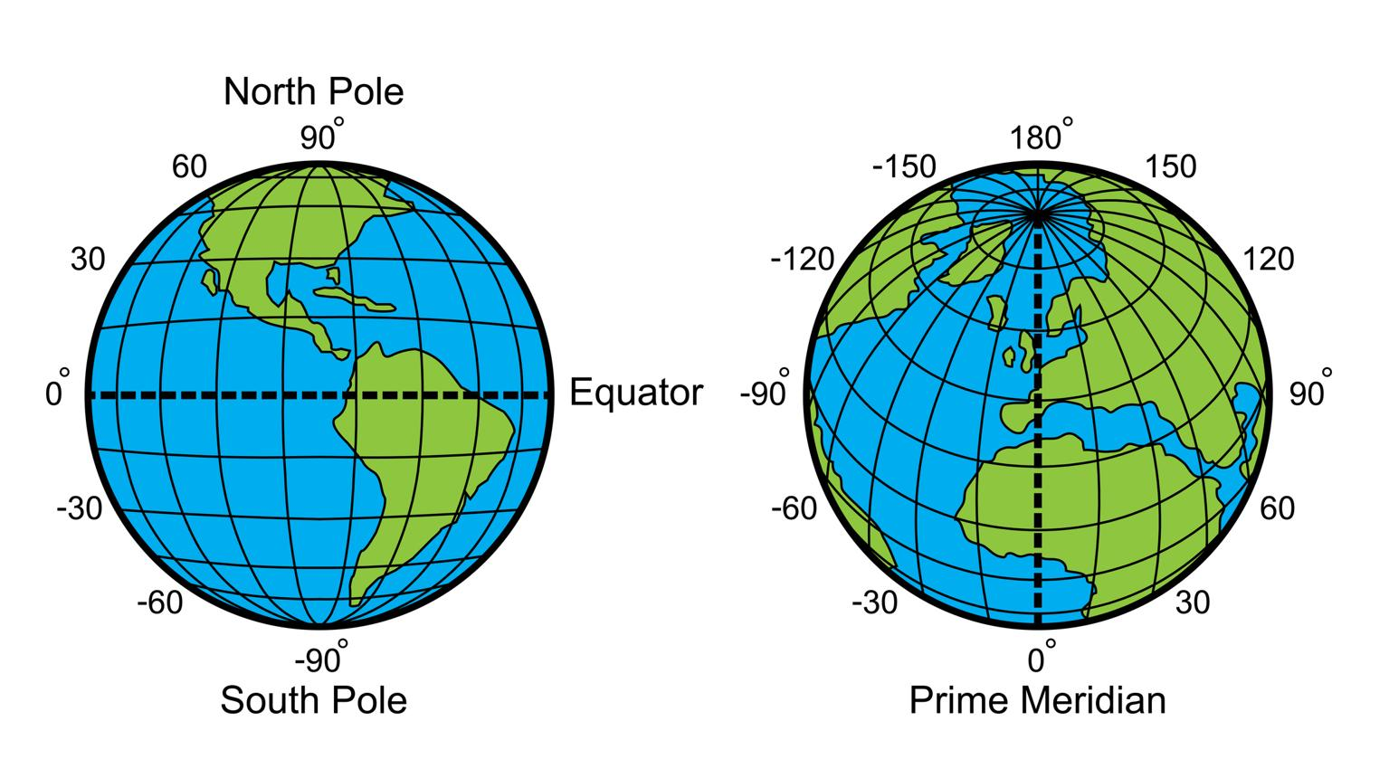

Example
City | Latitude | Longitude
Delhi | 28.6139 | 77.2090
Mumbai | 19.0760 | 72.8777

8.2 Plotting Longitude and Latitude
Steps to Create a Basic Map
Step 1: Open Tableau
Connect your dataset.
Step 2: Check Geographic Fields
If Tableau does not automatically detect location:
- Right-click field
- Select Geographic Role
- Choose:
  - Country
  - State
  - City
  - Postal Code

Step 3: Create Map
- Drag Longitude (generated) → Columns
- Drag Latitude (generated) → Rows
- Drag location field (State/City) → Marks card → Detail
Tableau automatically creates a map.

Example of Latitude & Longitude Mapping
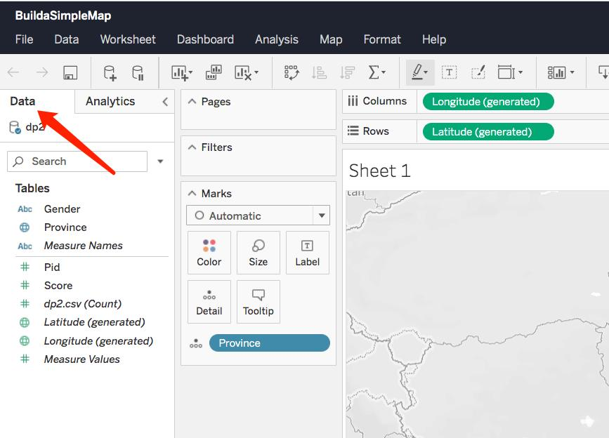
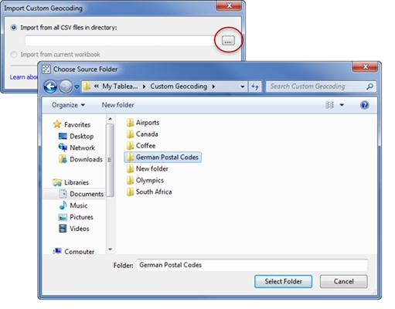

Creating Symbol Maps
Steps
- Drag Sales → Size
- Drag Profit → Color
- Drag Region → Label
Now the map becomes interactive and analytical.

8.3 Editing Unrecognized Locations
Problem
Sometimes Tableau shows:
- Unknown location
- Ambiguous location
- Incorrect location
Example:
- “Bihar” may not map properly if spelling is incorrect.

Steps to Fix Unrecognized Locations
- Click the location indicator (bottom-right corner)
- Select Edit Locations
- Choose:
  - Correct Country/Region
  - Match unknown fields manually

Edit Locations Window
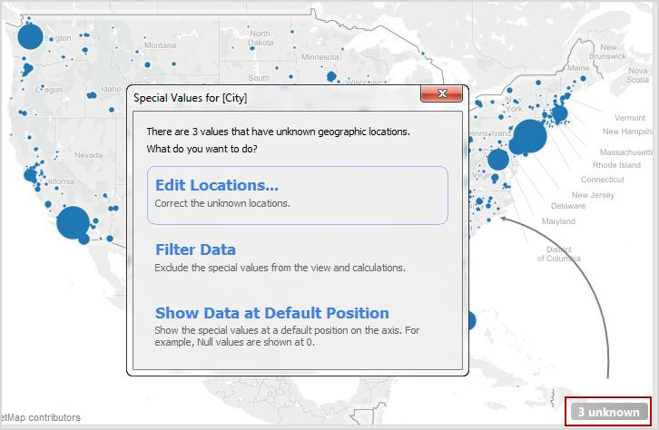
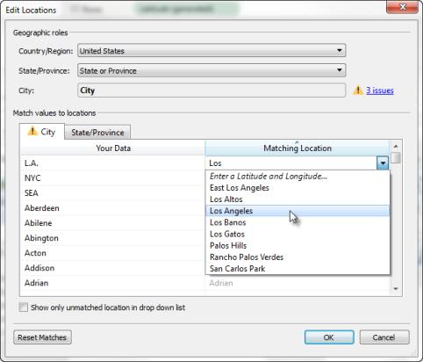


8.4 Customizing Geocoding, Polygon Maps & WMS
A. Custom Geocoding
Definition
Adding your own geographic coordinates to Tableau.
Example
You can map:
- Store locations
- Delivery routes
- Custom districts

Steps
- Prepare Excel with:
  - Place Name
  - Latitude
  - Longitude
- Connect data to Tableau
- Drag Longitude → Columns
- Drag Latitude → Rows
- Drag place name → Detail

Polygon Maps
Definition
Polygon maps create filled geographic shapes.
Examples:
- State boundaries
- Campus layout
- Election maps

Polygon Map Example
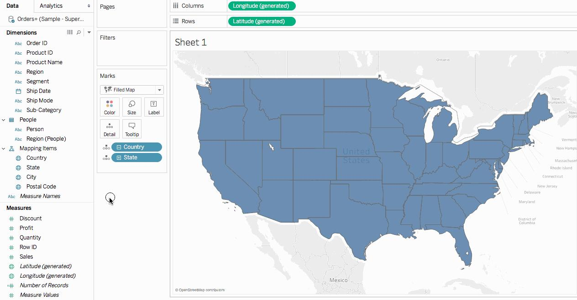
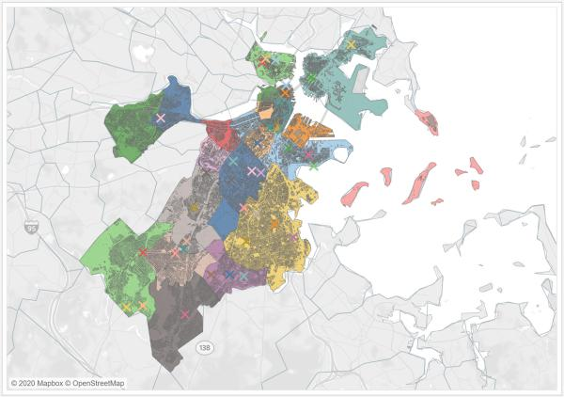
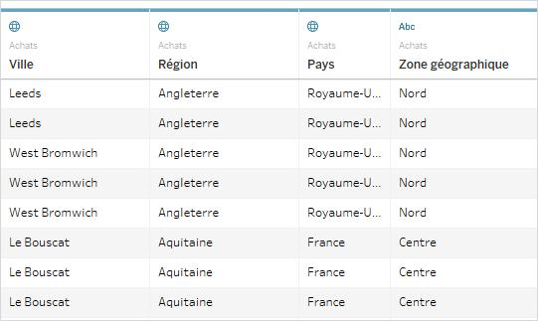

Steps to Create Polygon Map
- Import polygon coordinate dataset
- Drag:
  - Longitude → Columns
  - Latitude → Rows
- Change Marks type → Polygon
- Drag polygon ID → Detail
- Drag path/order field → Path

WMS (Web Mapping Services)
Definition
WMS allows Tableau to use external map servers.
Examples:
- Satellite maps
- GIS layers
- Government map services

Steps to Add WMS
- Map → Background Maps → WMS Servers
- Click Add
- Enter WMS URL
- Select layers
- Apply

8.5 Working on Background Images
Definition
Background images allow custom maps or floor plans.
Examples:
- Office layout
- Mall map
- Factory layout
- Seating arrangement

Add Background Image Steps
- Map → Background Images
- Select Data Source
- Click Add Image
- Browse image
- Set X and Y coordinates

Background Image Example
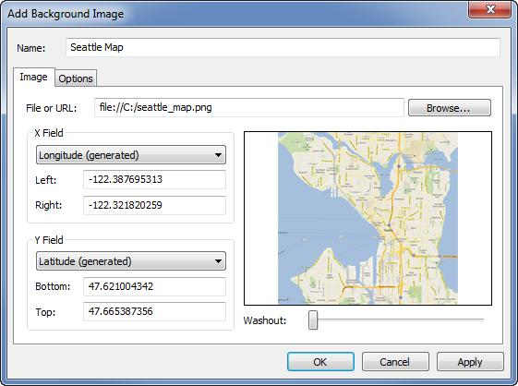
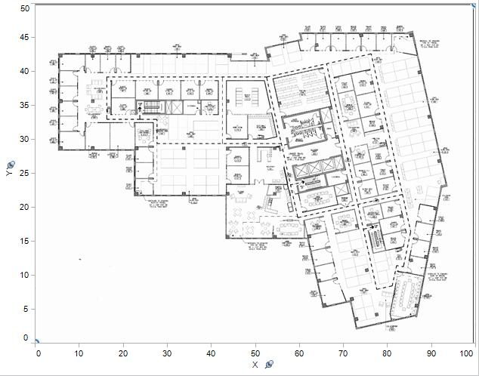
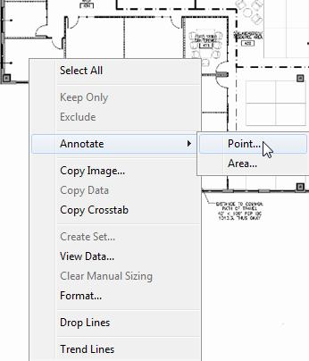

8.6 Plotting Points on Images & Generating Coordinates
Use Case
Plot:
- Seats
- Machines
- Rooms
- Product shelves
on a custom image.

Steps
Step 1: Add Background Image
Step 2: Create Coordinate Data
Example:
Item | X | Y
Seat A | 20 | 50
Seat B | 35 | 60

Step 3: Plot Coordinates
- X → Columns
- Y → Rows
- Item → Detail

Coordinate Plotting Example
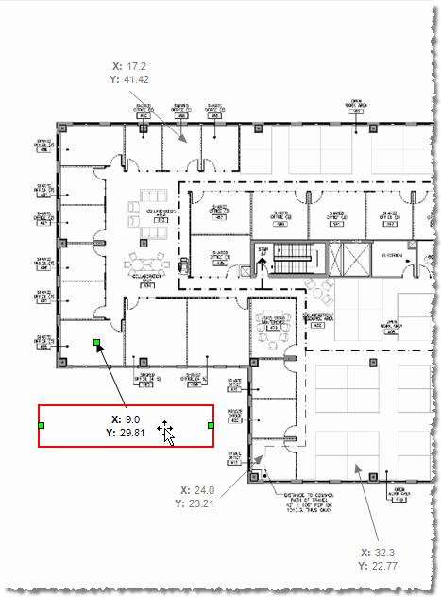

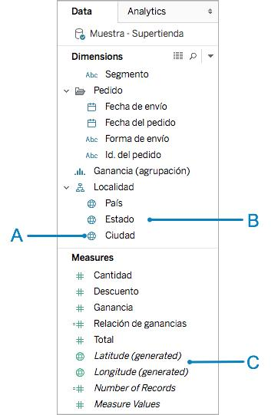

8.7 Map Visualization & Custom Territories
Types of Map Visualizations
Map Type | Purpose
Symbol Map | Show points
Filled Map | Show regions
Density Map | Show concentration
Heat Map | Visual intensity
Polygon Map | Custom boundaries

Density & Heat Maps
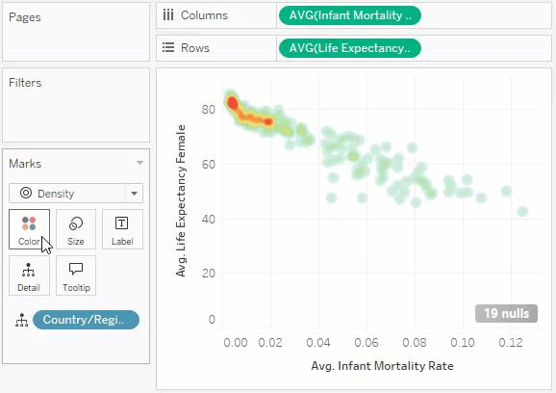
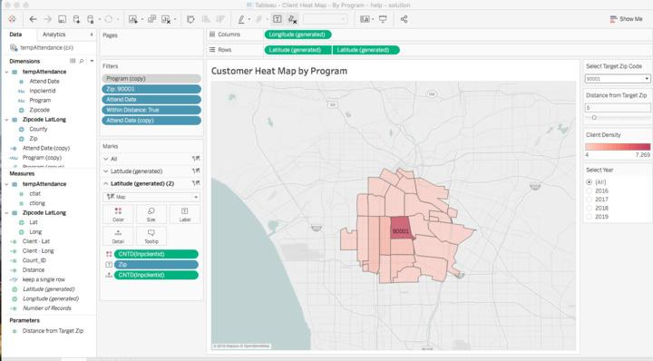
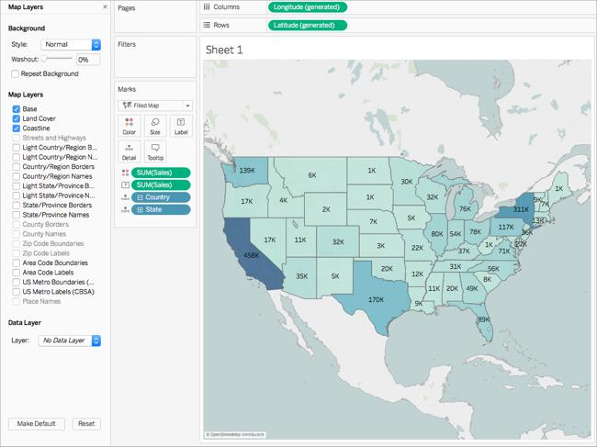

Custom Territories
Definition
Grouping geographic areas manually.
Example:
- North Zone
- South Zone
- Sales Territory

Steps to Create Territories
- Select multiple states on map
- Right-click
- Choose Create Territory
- Rename territory

  - Symbol Map (Show Points)
Double-click Geographic Field
Step-Double-click:
- State
OR
- City
OR
- Country
Tableau automatically creates a map.

Step-Add Sales
Drag:
- Sales → Size
Now bubble size represents sales.

Step-Add Profit Color
Drag:
- Profit → Color
Now:
- Green = Profit
- Red = Loss

  - Filled Map (Show Regions)
Step-Create Map
Double-click:
- State
Step-Change Marks Type
In Marks card:
- Click dropdown
- Select → Map
OR
Select:
- Show Me → Filled Map
Step-Add Sales
Drag:
- Sales → Color
Now states are color-filled.
Step-Add Labels
Drag:
- State → Label
(Optional)

3. Density Map (Show Concentration)
Step-Create Symbol Map
Double-click:
- City
Step-Change Marks Type
Marks dropdown →
Select:
- Density
Step-Add Order ID
Drag:
- Order ID → Detail
More orders create denser areas.

4.Heat Map (Visual Intensity)

Step-Drag Fields
Drag:
- Sub-Category → Rows
- Region → Columns

Step-Change Marks Type
Marks →
Select:
- Square

Step-Add Measures
Drag:
- Sales → Color
- Profit → Size

Business Uses
- Sales region analysis
- Market segmentation
- Delivery planning

8.8 How to Create Map Projects in Tableau
Sample Project Ideas
Project | Description
Sales by State | Regional sales analysis
Delivery Tracking | Shipment locations
Store Performance | Store-wise profit
Customer Distribution | Customer spread analysis
Population Analysis | Demographic mapping

Recommended Dashboard Layout
Sheet | Visualization
Sheet 1 | Symbol Map
Sheet 2 | Filled Map
Sheet 3 | Sales Trend
Sheet 4 | KPI Cards

Steps for Map Dashboard
- Create multiple maps
- Add filters
- Add legends
- Create dashboard
- Enable map actions

Tableau Map Dashboard Examples
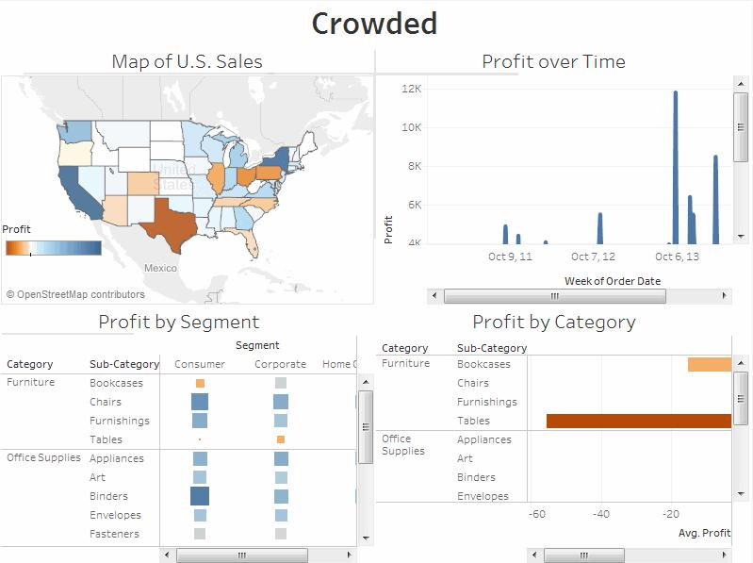
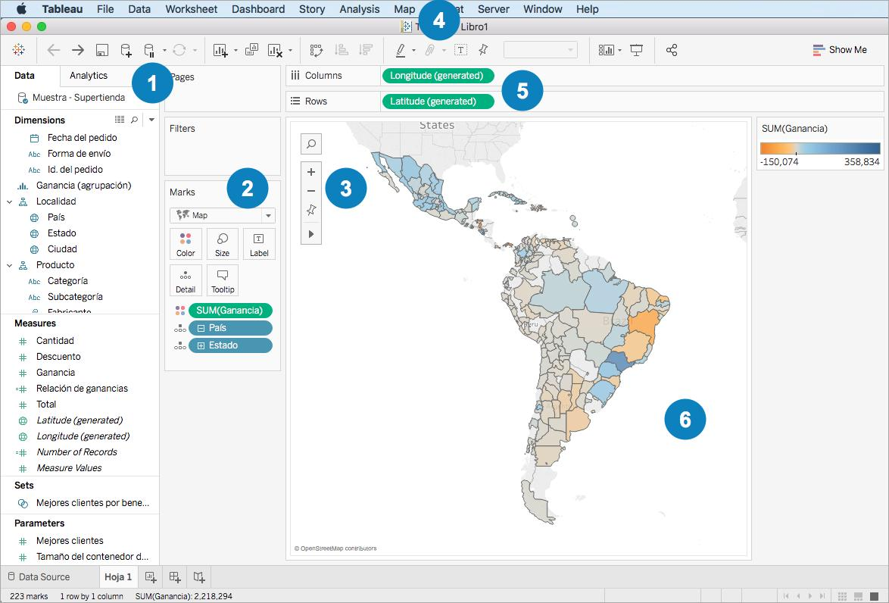
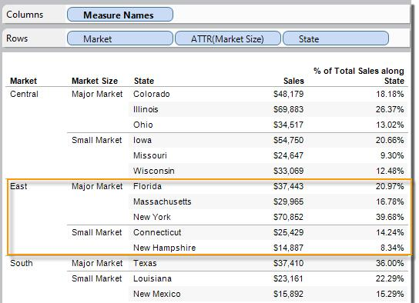
8.9 Creating Dual Axes Maps & Editing Locations
Dual Axes Maps
Definition
Combining two map layers into one visualization.
Example:
- Sales bubbles + Profit density
- Store points + Routes

Steps to Create Dual Axis Map
Step 1
Drag:
- Longitude → Columns
- Latitude → Rows
Step 2
Duplicate Latitude field.
Step 3
Right-click second axis → Dual Axis
Step 4
Customize:
- First layer → Filled Map
- Second layer → Circle marks

Dual Axis Map Example
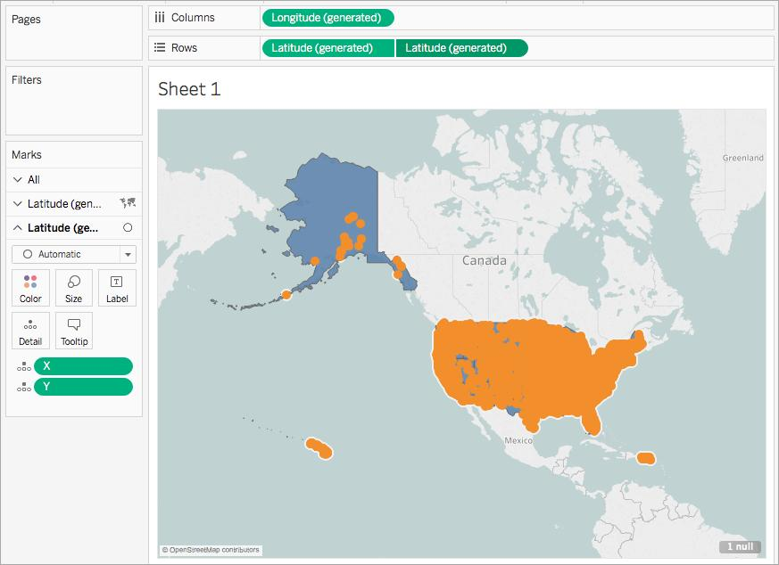



Editing Locations
Steps
- Map → Edit Locations
- Match:
  - Country
  - State
  - City
- Resolve unknown locations manually

